Problem statement:

Create a reusable component for CRUD Operations.

1. The component should integrate with an API(any api of your choice) to implement Create ,Update ,Read and Delete operations.

2. Displays the data in a table which has add ,edit and delete actions.(You can use any third party datatable library like https://l-lin.github.io/angular-datatables/#/getting-started or just keep a simple table tag)

3. The table should be capable of formatting data in 3 formats (Amount/Number/Text)

4. The component should accept all the options as a hardcoded Json object.

5. The component should support 3 events: edited ,added ,deleted which will be called on the respective actions

For API you can use a dummy api service like http://dummy.restapiexample.com/ or any of your choice. You can reach to Abdul Aleem if you are not able to get the API working.

Below is the case which shows what a set options should produce as an output. the add/edit form can be pop up (or) a child route.

Test Case:

var options = {

BaseAPIUrl: "http://dummy.restapiexample.com/api/v1",

Get: "employees", //calls---> http://dummy.restapiexample.com/api/v1/employees

edit: "update/:id",

add: "create",

delete: "delete",

dataTableOptions: {

Columns:[

{name: "Name", data: "employee_name" ,format:"text"},

{name: "Age", data: "employee_age", format:"number"},

{name: "Salary", data: "employee_salary",format:"amount" }

]

},

events: {

edited: function () {},

added: function () {},

deleted: function () {},

}

};

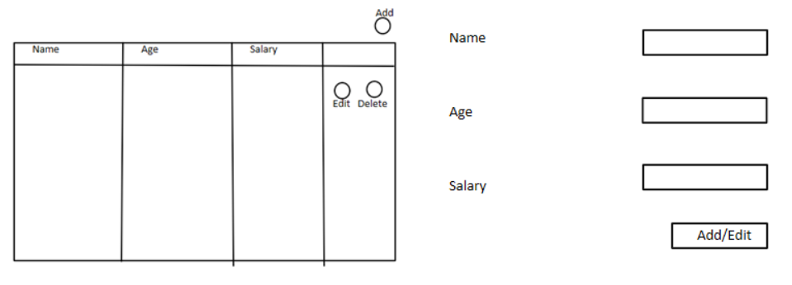

The Scoring will be done based on the below criteria:

1. **Feature Set**: No. of features implemented.

2. **Concepts:**No. of Angular concepts used and if they are used properly.

3. **Maintainability/Extensibility**: How easy it is to add more features in future (this has more weightage for senior folks)

All the above criteria will be judged against the experience of the candidate. More experienced devs will be scrutinized more.

**Instructions:**

1. **Stack blitz account creation**: It is not mandatory to create account on stack blitz account provided you can save your progress without creating an account. if you feel comfortable working in local then feel free to do so but you will  need to deploy the application somewhere of your own choice. may be something like netlify.com might help. but stack blitz will make my life easier for evaluation.

2. **Datatables**: For the table, I would highly recommend using the angular-datatables or any plugin of your choice instead of not using any as it will make your life easier.

3. **There are no points for styling**. But try your best to style it properly.

4. **Formattings**: the templates for formatting are like this: Amount: $3.00K or $156.23M, Number: 3,000 or 1,562,300, Text: 3000 or Abdul Aleem.

5. **Readme.txt format**:  
      Feature List:  
      1. Add Record Implemented  
      2. Edit Record Implemented  
      3. Sorting added to the grid  
            How to use: Click on the header to sort.  
      4. Formatting Implemented.  
            How to use: pass format:'Amount/Text/Number' in the column object of the component options.  
      etc....

·         The submission time is 2 weeks so, the last day of submission will be 8th July 2020.

Get: api/CRUD/GetOrders?OrderID=0

POST: /api/CRUD/SaveOrders

DELTE: api/CRUD/DeleteOrder?OrderID=4

Endpoint: https://angularcrudapi.gear.host/